‘Yule’ Centrifugal fan

MODEL CAPACITY :
- FLOW RATE FROM 2000 M³/Hr TO 30,00,000 M³/Hr
- PRESSURE UPTO 4900 mm WG
- TEMPERATURE UPTO 450 DEG.C (CONTINUOUS)
- SPEED UPTO 3000 RPM
- POWER UPTO 6 MW FOR SINGLE FAN

SPECIALITY:
- HIGH EFFICIENCY
- GUARANTEED PERFORMANCE
- SOUND MECHANICAL RUNNING, LOW NOISE
- QUICK DELIVERY
- ONE YEAR ON-SITE WARRANTY (excl. wear liners)
- VERY RELIABLE SERVICE BACK-UP BY REAL EXPERTS IN THE FIELD

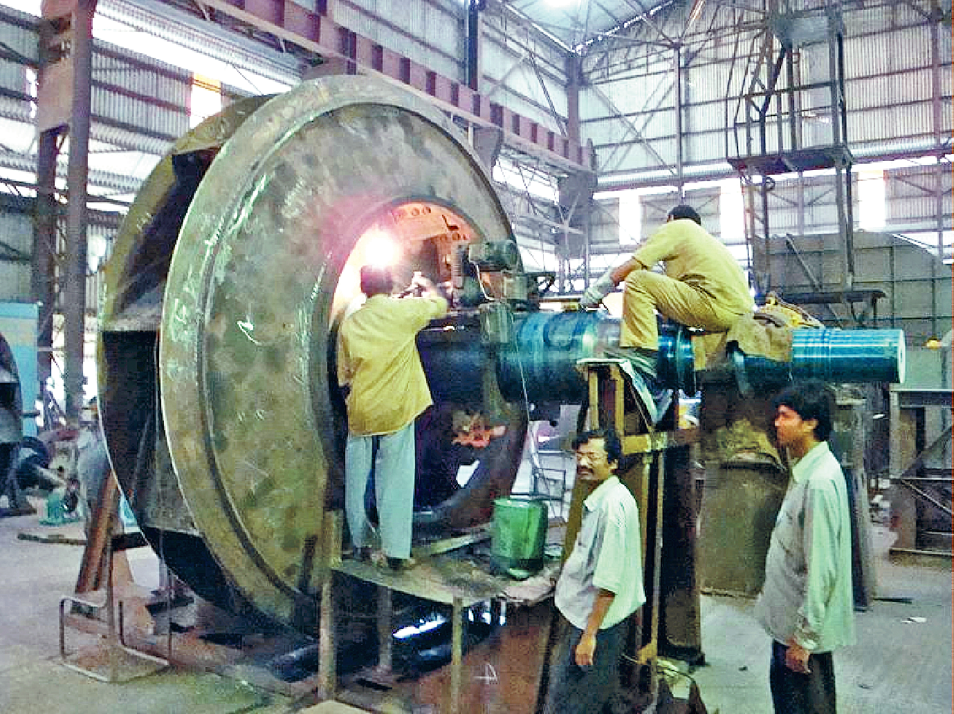

FAN MODEL SELECTION :
- BEST EFFICIENCY MODEL SELECTED BY A SPECIAL SOFTWARE PACKAGE
- ESTIMATED PERFORMANCE CURVE GENERATED.
- FAN DESIGN (IMPELLER, SHAFT –> MATL, PLATE THK, WT., WK² etc.) DONE BY COMPUTER AIDED DESIGN (3D)
- BEARING, COUPLING SELECTION, DAMPER TORQUE etc. ALSO DONE BY Auto-CAD.
- SPEED-TORQUE CURVE GENERATED- FOR MOTOR SELECTION BY MOTOR MANUFACTURER.
Efficiency of different Models of Fan

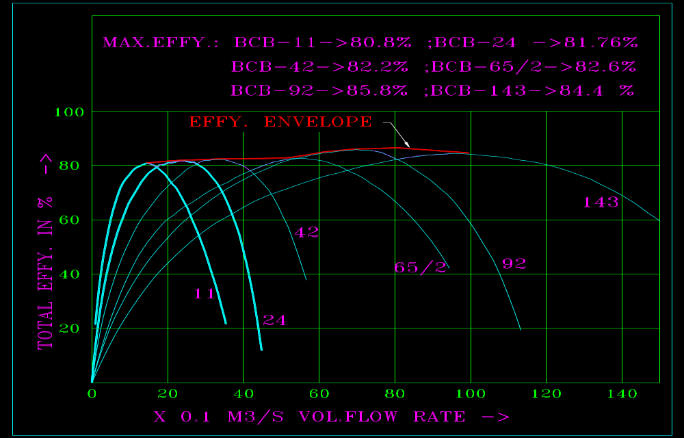

Estimated Performance Curve of Fans

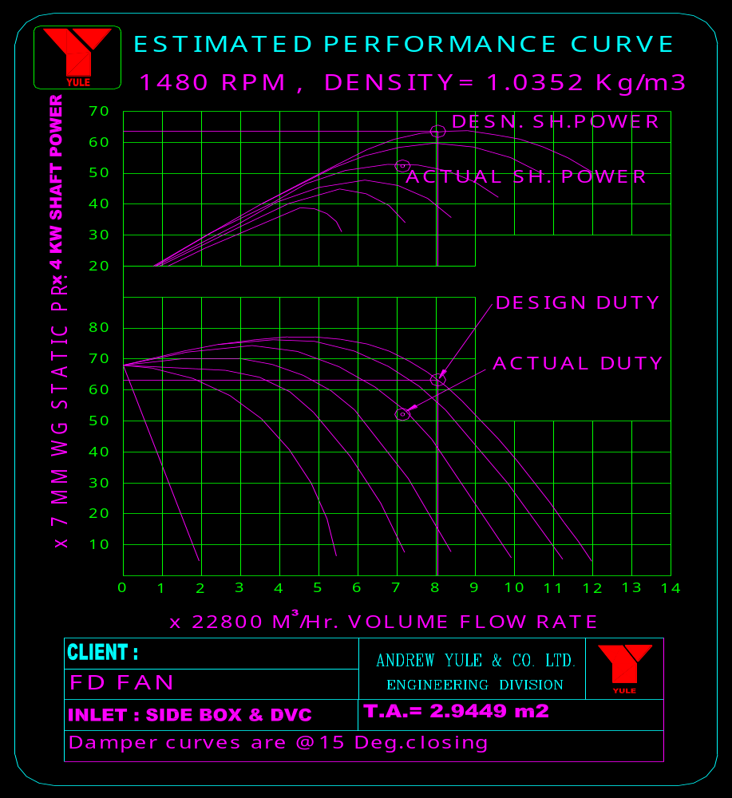

Estimated Speed-Torque Curve of Fans
(required for Motor selection)

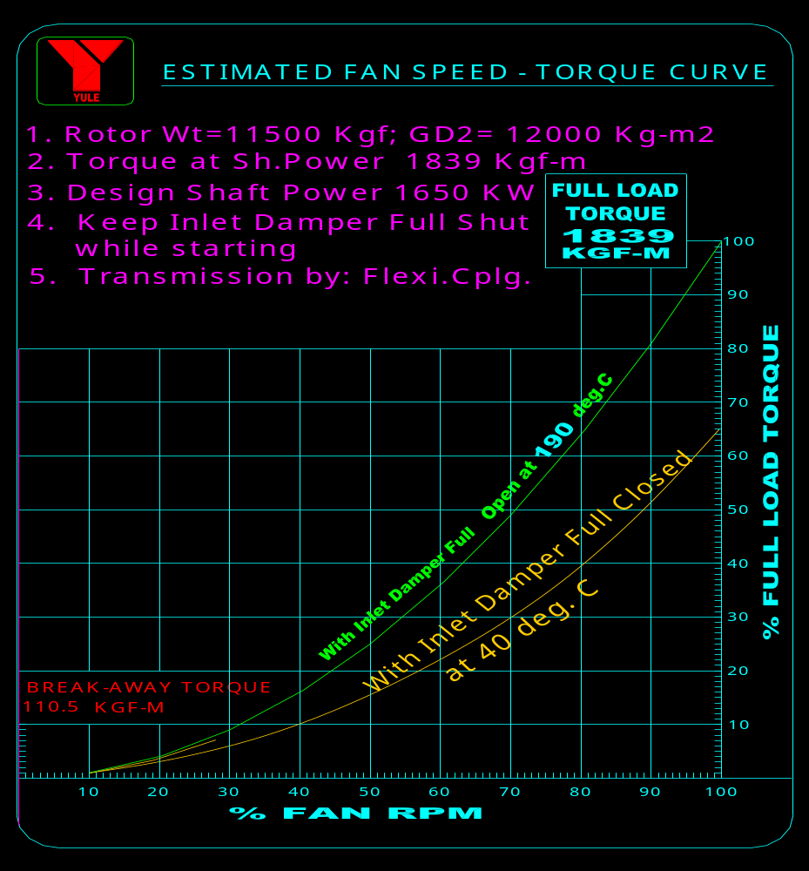

RANGE OF APPLICATION:

POWER PLANTS:

- ID FAN - UPTO 21 LAC M³/Hr.
-> NTPC- RIHAND TPS: 3186 MM DIA IMPELLER; 2060280 M³/Hr.; 352 MM WG ST. PR; 2.82 MW; 720 RPM; IMP+SHAFT WT = 23.4 T
-> NTPC-TALCHER TPS: 2560 MM DIA IMPELLER; 684000 M³/Hr.; 350 MM WG ST. PR.; 0.8 MW; 740 RPM; IMP+SHAFT WT = 9.4 T

- FD FAN -> UPTO 6 LAC M³/Hr
-> WBPDCL- KOLAGHAT TPS : 2045 MM DIA FAN ; 515520 M3/HR ; 425 MM WG ST.PR. ; 0.95 MW ; 980 RPM

- PA FAN :
UPTO 1 LAC M³/Hr; 1500 mm WG ST.PR; 1500 RPM

- SA FAN :
UPTO 0.3 LAC M³/Hr; 1800 MM WG ; 3000 RPM

STEEL PLANTS :

- SINTER EXHAUST FAN -> UPTO 12 LAC M³/Hr
-> VIZAG & ROURKELA STEEL PLANT: 3660 & 3695 DIA FAN ; 9-11 Lac M3/HR ; 1500-1600 MM WG ST.PR. ; 4.2 – 5.2 MW ; 990 RPM
-> TISCO : 4010 MM DIA FAN ; 9.3 Lac M3/HR ; 1662 MM WG ST.PR. ; 4.97 MW ; 980 RPM

- GB, CA & ID FANS:
UPTO 3 LAC M³/Hr; 750 mm WG ST.PR; 2980 RPM

CEMENT PLANT:

for all types of application viz. PA, Raw Mill, Coal Mill, Cement Mill, Cooler, Separator, Bag House, ESP/Waste Gas/P.H. etc.
Capacity Range: 2,000 – 8,00,000 m3/hr ; St. Pr: 100-1800 mm Wg.
Temp. up to 420 deg.C ; Speed: 600-3000 RPM ; Effy. up to 87%

- Raw Mill Fan:
-> GRASIM PLANT: 2910 DIA Double Inlet Fan ; 6.3 Lac M³/Hr; 970 mm WG ST.PR. ; 105 deg.C; 2.1 MW ; 990 RPM
- Kiln ESP Fan:
-> PRIYADARSHINI CEMENT: 2265 DIA Double Inlet Fan; 4.98 Lac M³/Hr; 175 mm WG ST.PR. ; 368 KW; 740 RPM
- Cement Mill Fan:
-> VIKRAM CEMENT : 1980 DIA Single Inlet Fan ; 1.4 Lac M3/HR ; 1020 mm WG ST.PR. ; 475 KW ; 985 RPM

BEARINGS AND BEARING HOUSINGS OF
‘YULE’ MAKE

- WHITE METAL LINED SLEEVE BEARING (2” TO 10” SIZE ) – RING LUBRICATED , WATER COOLED

- PRESSURE FED WHITE METAL LINED SLEEVE BEARING (2” TO 12” SIZE)

- HOUSINGS FOR DOUBLE ROW SPHERICAL ROLLER BEARINGS (DRSR) -> 60 MM DIA UPTO 200 MM DIA

YULE make Ring Lubricated DRSR Bearing Housing

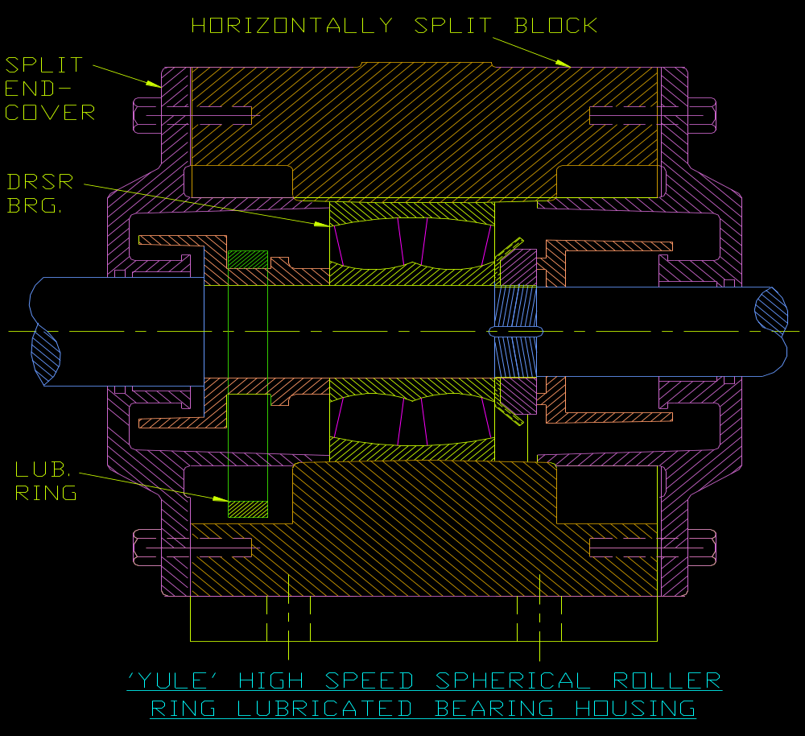

YULE make Uniblock Housings

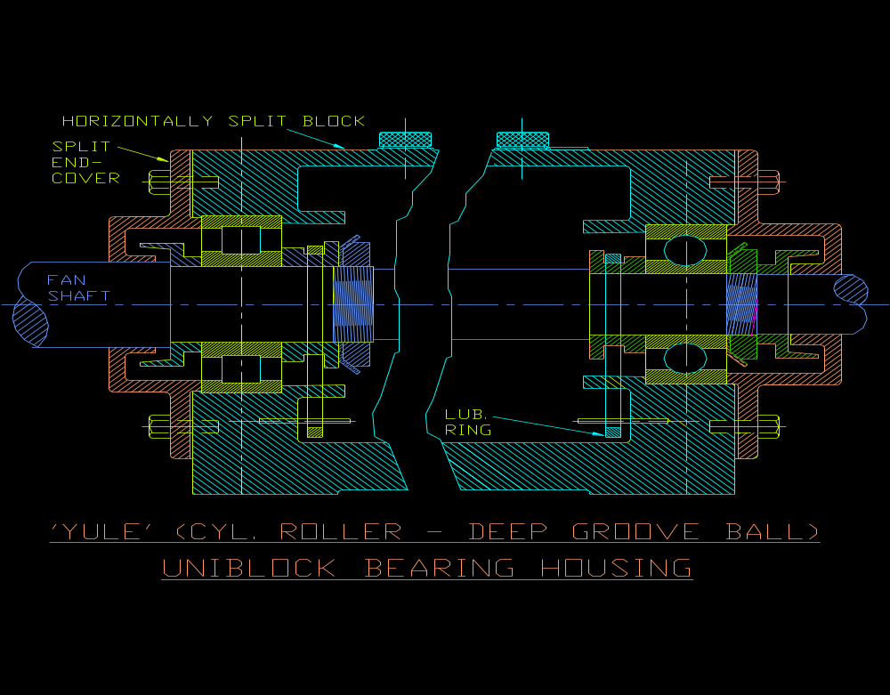

QUALITY PLAN FOR YULE FANS :

- PLATES : CHEMICAL , PHYSICAL TESTS AND ULTRASONOGRAPHY
- SHAFT : CHEMICAL , PHYSICAL TESTS AND ULTRASONOGRAPHY .
- HUB : CHEMICAL & PHYSICAL TESTS
- WHITE METAL BEARINGS : ULTRASONOGRAPHY AND PRESSURE TESTING OF BRG.HOUSING
- WELDING JOINTS : FOR IMPELLER -> FILLET JOINTS DP/ MPI TESTED ; BUTT JOINTS -> MIN. 30% RADIOGRAPHY CARRIED OUT
- STATIC COMPONENTS : QUALITY OF WELD & MANUFACTURING STRICTLY CONTROLLED
- STRESS RELIEVING IN OWN SR FURNACE
- DYNAMIC BALANCING : ALL IMPELLERS AT SHOP AS PER ISO:1940 GRADES 6.3 / 2.5
- FAN ASSEMBLY : CARRIED OUT AT SHOP TO CHECK MATCHING OF CRITICAL COMPONENTS
- PERFORMANCE TEST & MECHANICAL RUN TEST : CARRIED OUT , AS PER CONTRACT, AS PER BS: 848 PART .

WEAR PROTECTION IN FANS :

- BLADE PROVIDED WITH LINERS (50% TO 100% WIDE) :
(a) WITH HARD-SURFACING (650 BHN) or
(b) HARDENED PLATES (HARDOX- 400/500) USED AS LINER

- CENTRE SHEET LINERS (Adjacent to blade area) PROVIDED

- OPEN BLADED IMPELLERS USED FOR HEAVY DUST LOAD
- Volute Casing also provided liner , if required
- REMOVABLE LINERS FOR EASY REPLACEMENT

VIBRATION AND NOISE :

- VIBRATION RANGE OF MACHINE CLASS-III FANS ARE AS PER ISO: 2372 / VDI 2056 -> 1.8 MM/S TO 11 MM/S ; NORMAL VALUE 2 TO 4 MM/S

- NOISE LIMIT : 85 dB @ 1M FROM FAN without or with SILENCER / ACCOUSTIC LAGGING/ ACCOUSTIC ENCLOSURES – as may be the case

PERFORMANCE TEST :

Testing Facility :
- Own Test Bay
- Test Duct upto 2m dia
- Calibrated testing Instruments
- Testing as per BS:848:Part-I
- Test Report & Curve generated by Computer
- Expert Testing Team

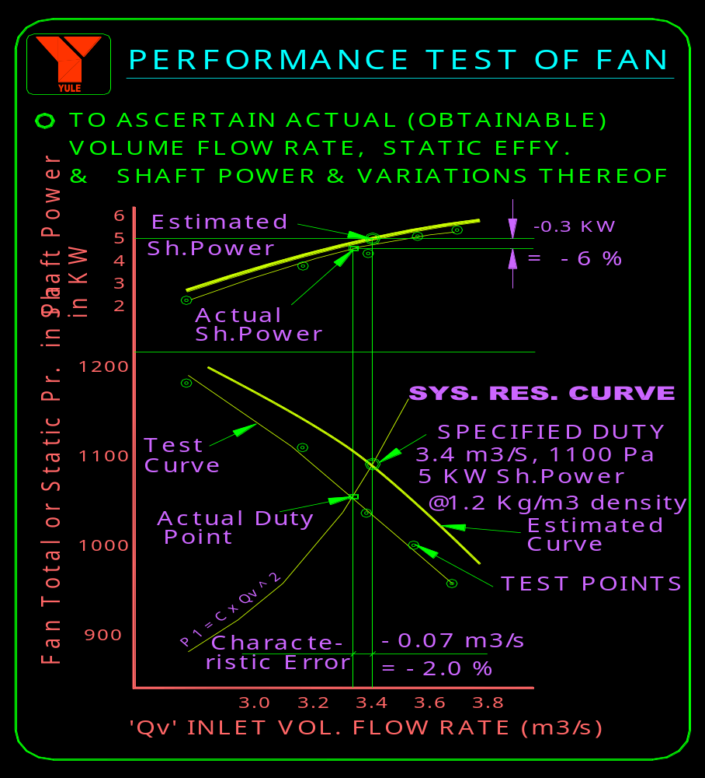

Fan Operation : Myth and Reality –

- Dynamic Balancing to be done at Rated Speed of Fan -> Not essential. Balancing Machines can do the job very well at their rated speeds of 200/ 400 RPM as they are sensitive enough and calibrated for these speeds

- Shaft to be Dynamically Balanced : Not required -> As Shaft unbalance is within 0.1% of Impeller’s Permissible Residual unbalance

- Always Use Silencer to reduce Noise : System Resistance will increase and power may go up by 5 to 15% .

CONTACT INFORMATION :

- For Fan, Spares enquiry/ Offers:
Mr. A.K. Dutta - +919903032720 , Mr. Sandipan Das: +919831501221 / +919836744337.
Mr. Swarup Ghosh: +918100975193.
- For ESP/ Bag Filter /spares enquiry/ Offers & WPC Execution:
Mr. Sourav Sengupta: + 919830853319. / Mr. T. K. Chattopadhyay: +919874420015.
- For Fan PO/ Contracts related matters:
Mr. Vivek Dolai: +919836744825. / Mr. EP Radhakrishnan: 0332242 5979
Mr. Amit Ganguly: +919874573880 , Mr. Sarasij Ghosh - +919433660240
- For Installation & Service related issues:
Mr. A. K. Chowdhury: +919830286070. / Mr. S. N. Mullick: +919836744823.

‘Yule’ Air Pollution Control

Electro Static Precipitator ( ESP )

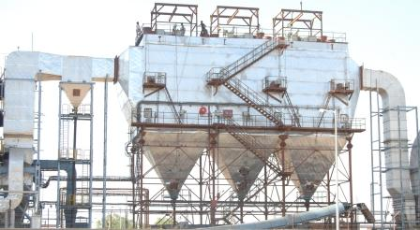

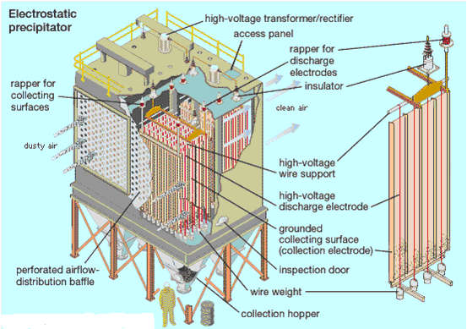

Pulsejet & Reverse jet Bag Filter / Bag House

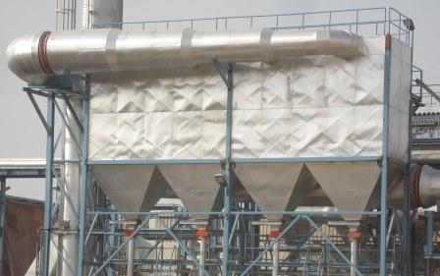

Fume Extraction & Cleaning Systems .

Gas Conditioning Towers .

De-dusting Systems in Electric Arc Furnaces .

